CSA05-DATABASE MANAGEMENT SYSTEMS
LAB OBSERVATION
EXPERIMENT:20
AIM:
To implement Replace, Repeat, Reverse, Right, Left,Rpad and LpadString Functions using MySQL.
SQL QUERIES:
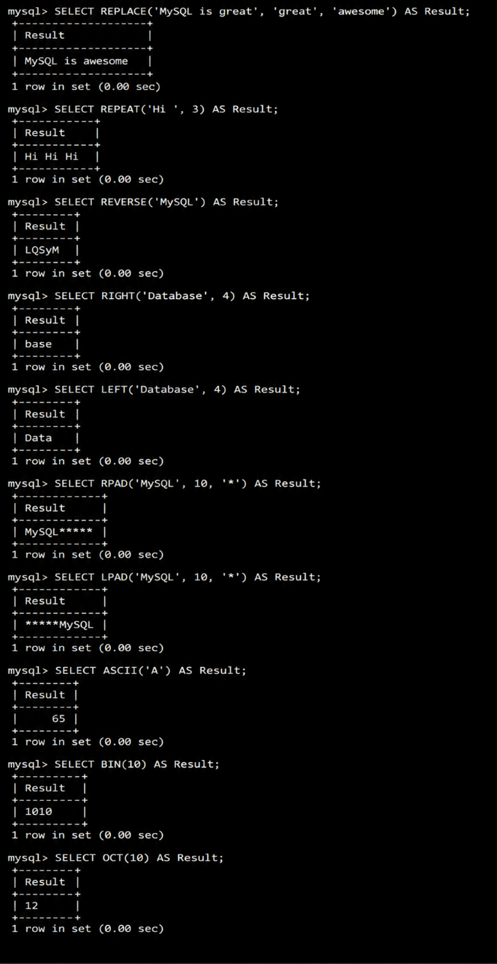

RESULT:
Thus the trigger is executed successfully.

